**eSwatini (Swaziland) country profile**

Published

7 October 2019

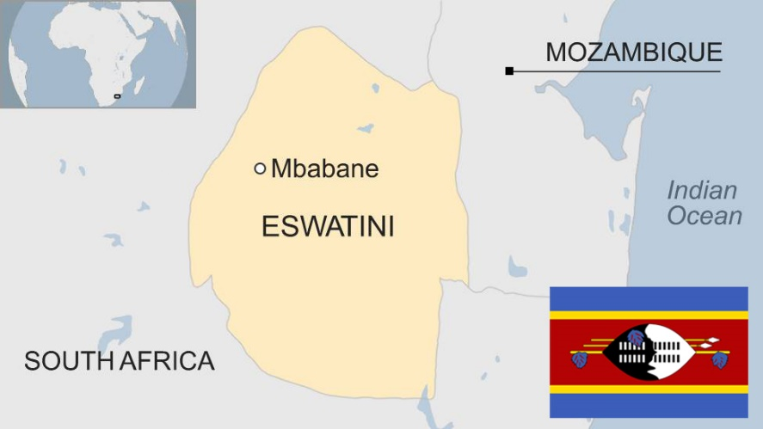

**The kingdom of eSwatini is one of the world's last remaining absolute monarchies.**

The king rules by decree over his million subjects, most of whom live in the countryside and follow traditional ways of life.

In 2018 the king announced that the country, hitherto known as Swaziland, would henceforth be called eSwatini, a move critics said was made without consultation and needed a constitutional change.

The country exports sugar, and many Swazis work in South Africa and send their earnings home.

According to UNICEF, eSwatini has the highest HIV prevalence rate in the world. The HIV-Aids virus has killed countless Swazis and left thousands of orphans. Some 210,000 people are estimated to be living with HIV.

* Read profiles by [BBC Monitoring](http://www.bbc.co.uk/monitoring)

**King: Mswati III**

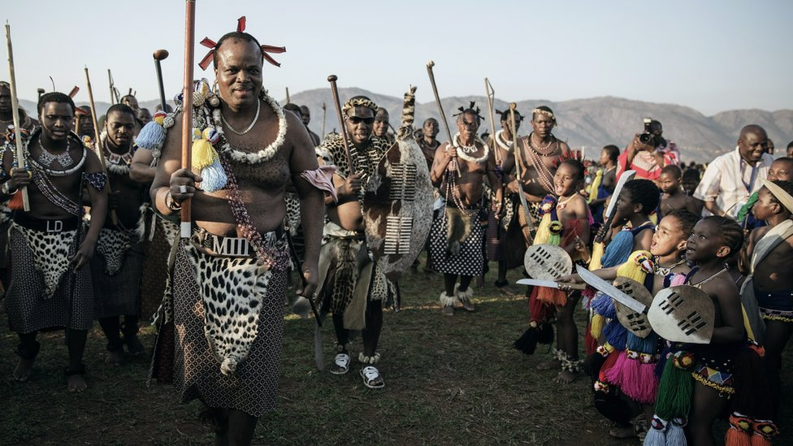image copyrightGetty Images

King Mswati III was crowned in 1986 at the age of 18, succeeding his long-serving father King Sobhuza II, who died at the age of 82.

The king, who is known as Ngweyama - "the lion" - often appears in public in traditional dress and has many wives.

He rules by decree and has been criticised for the heavy-handed treatment of opponents and for requesting public money to pay for new palaces and luxury cars.

Protesters angered by economic decline have become increasingly vocal in demanding political reform.

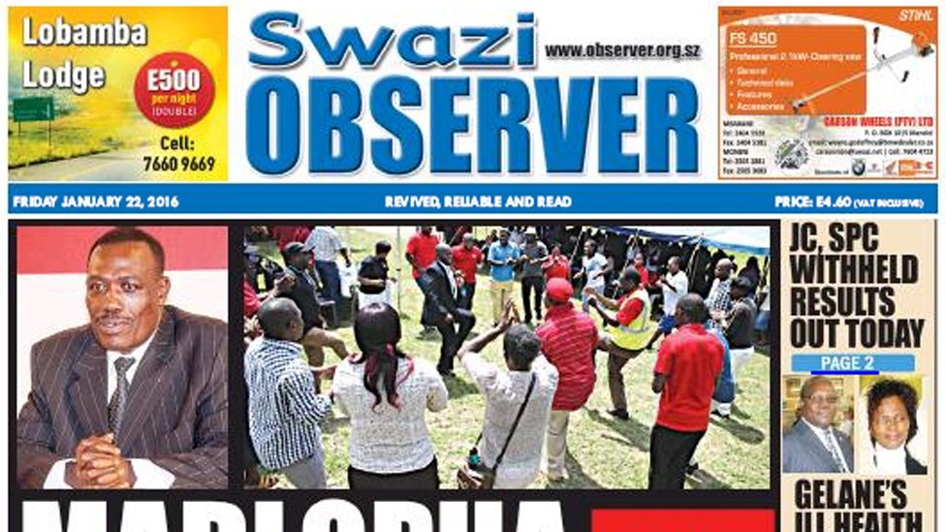image copyrightSwazi Observer

State control of the media is strong and journalists are liable to be prosecuted for criticising the government.

The government does not restrict access to the internet, but few Swazis can afford to go online.

# eSwatini profile

Published

3 September 2018

**A chronology of key events:**

**1894** - Britain and the Boer Republic of Transvaal jointly rule Swaziland.

**1907** - Swaziland becomes a British High Commission territory.

**1921** - King Sobhuza II succeeds to the throne.

**1962** - The Ngwane National Liberatory Congress (NNLC) is formed.

**1964** - Swaziland's first constitution enters into force.

**1964** - King Sobhuza establishes a political party, the Imbokodvo National Movement (INM). It secures all the seats in the new Legislative Council.

**1967** - A new constitution comes into effect, providing for the introduction of self-government once independence is gained.

**1967** - The Legislative Council is dissolved. Elections to a new bicameral parliament - including a House of Assembly and Senate - take place. The INM gains all 24 elective seats in the lower house. Despite not gaining any seats, the NNLC emerges as the main opposition.

## Independence

**1968** - Swaziland is granted formal independence, within the Commonwealth, and adopts a new constitution. Authority is vested in the new parliament, a proportion of the members are nominated by the monarch.

**1972** - Elections to the House of Assembly see the INM retaining 21 seats and the NNLC gaining the remaining three.

**1973** - King Sobhuza suspends the constitution and bans political parties.

**1977** - The parliamentary system is abolished and replaced by traditional tribal communities.

**1978** - The new constitution enshrines electoral representation by 'Tinkhundla'. Under the system candidates are nominated by Tinkhundla's (local councils) and elected by secret ballot. The king retains the power to appoint a proportion of parliamentarians. Parliament's role is advisory.

**1979** - New parliament is opened.

## King Mswati III crowned

**1982** - The body advising on Swazi tradition - the Swaziland National Council - made up of members of the royal family, is renamed the Supreme Council of State (Liqoqo).

**1982** - King Sobhuza dies.

**1982** - Queen Mother Dzeliwe is authorised to act as Regent until Prince Makhosetive reaches 21.

**1983** - Queen Regent Dzeliwe is deposed. Queen Ntombi, Prince Makhosetive's mother, is made regent.

**1983** - The People's United Democratic Movement (Pudemo) is formed.

**1986** - Prince Makhosetive is crowned - three years early - and assumes the title of King Mswati III.

**1986** - King Mswati dissolves the Supreme Council of State (Liqoqo).

**1991** - King Mswati agrees to review the Tinkhundla system by setting up a commission. Pudemo rejects the commission.

**1992** - The king sets up a second commission to review political reforms.

**1992** - Pudemo rejects the second commission's proposals. King Mswati dissolves parliament and announces he will govern by decree until the elections.

**1997** - Half of the labour force observes a general strike called by the SFTU. The government declares the strike illegal.

## Aids epidemic

**2003** October - Parliamentary elections; pro-democracy activist Obed Dlamini wins a seat.

**2004** March - UN Aids envoy says Swaziland has the world's highest rate of HIV infection.

**2004** July - King proposes to build new royal residences to house some of his wives.

**2005** August - King signs a new constitution.

## Opposition protests

**2007** July - Thousands protest in the commercial capital Manzini to press for democratic reforms.

**2008** September - Opposition groups boycott elections as part of their campaign for multi-party elections.

**2010** September - Pro-democracy demonstrators march through Manzini, despite the arrest of some 50 activists the previous day.

**2011** November - Swaziland is hit by a budget crisis described by the IMF as "critical", with the government struggling to pay the salaries of public sector workers.

**2013** August, September - Parliamentary polls. Candidates participate as individuals because parties are barred from contesting elections.

**2018** April - King Mswati announces that the country is to change its name to eSwatini.